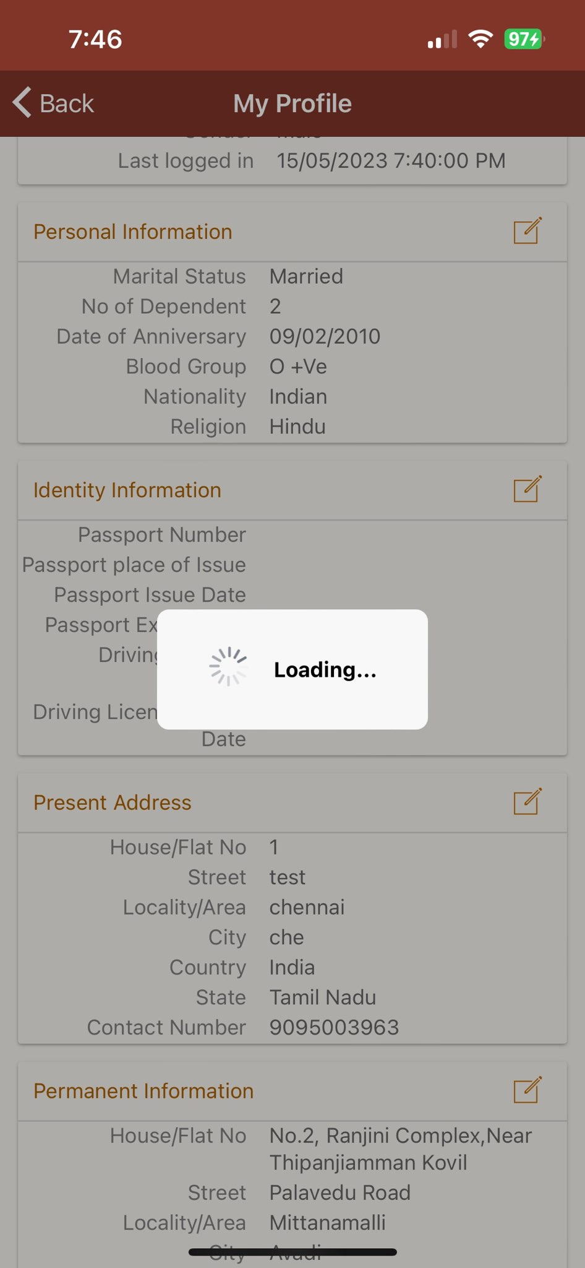It is loading more than 30 sec on pay slip, personal update

